Lab # 5 Threading
A thread is a sequence of such instructions within a program that can be executed independently of other code.

Identifying a thread

Each thread identified by an ID, which is known as Thread ID. Thread ID is quite different from Process ID. A Thread ID is unique in the current process, while a Process ID is unique across the system.
Thread ID is represented by type pthread_t

​Header file(s)
The header file which needs to be included to access thread functions

#include<pthread.h>
Then, how to compile C program with pthread.h library?
To compile C program with pthread.h library, you have to put -lpthread just after the compile command gcc thread.c -o thread, this command will tell to the compiler to execute program with pthread.h library.

​The command is:
gcc thread.c -o thread -lpthread

  - gcc is the compiler command.
  - thread.c is the name of c program source file.
  - -o is option to make object file (o/p file or executable file).
  - thread is the name of object file.
  - -lpthread is option to execute pthread.h library file.

- Create a thread and display numbers from 1 to 100;

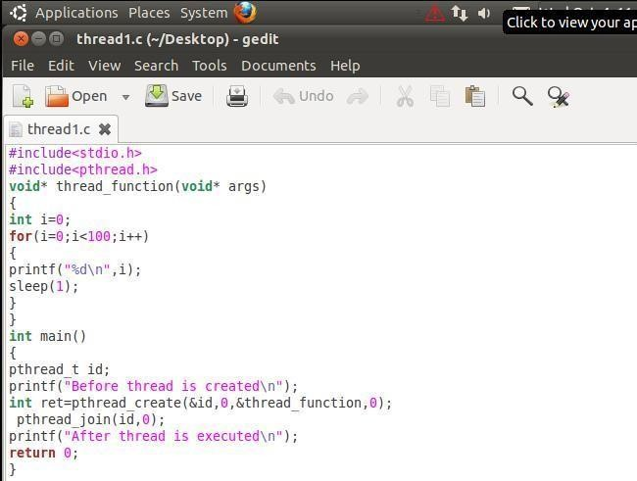
OUTPUT
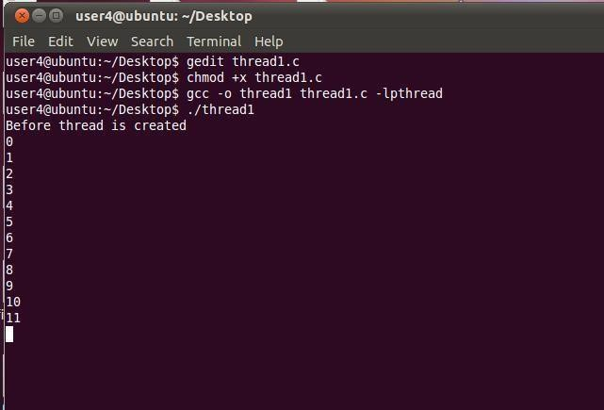
- Create two threads Thread1 and Thread2. Display even number in Thread1 and odd numbers in Thread2 from 1 to 100.Debug them and display their outputs by single stepping (running individual threads).
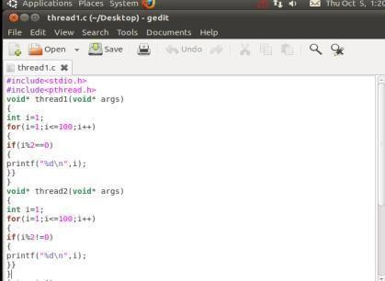

Debugging Individual Threads

GDB has the ability to debug individual threads, and to manipulate and examine them independently. This functionality is not enabled by default. To do so use set non-stop on and set target-async on. These can be added to .gdbinit. Once that functionality is turned on, GDB is ready to conduct thread debugging.
For example, the following program creates two threads.

OUTPUT

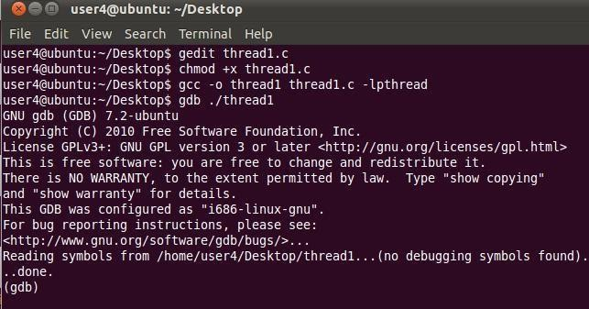
First set breakpoints on all thread functions; thread1, thread2, and main.
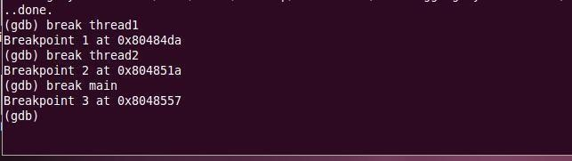
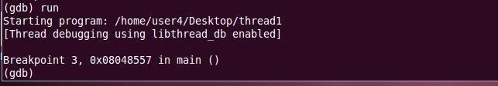
Then run the program.
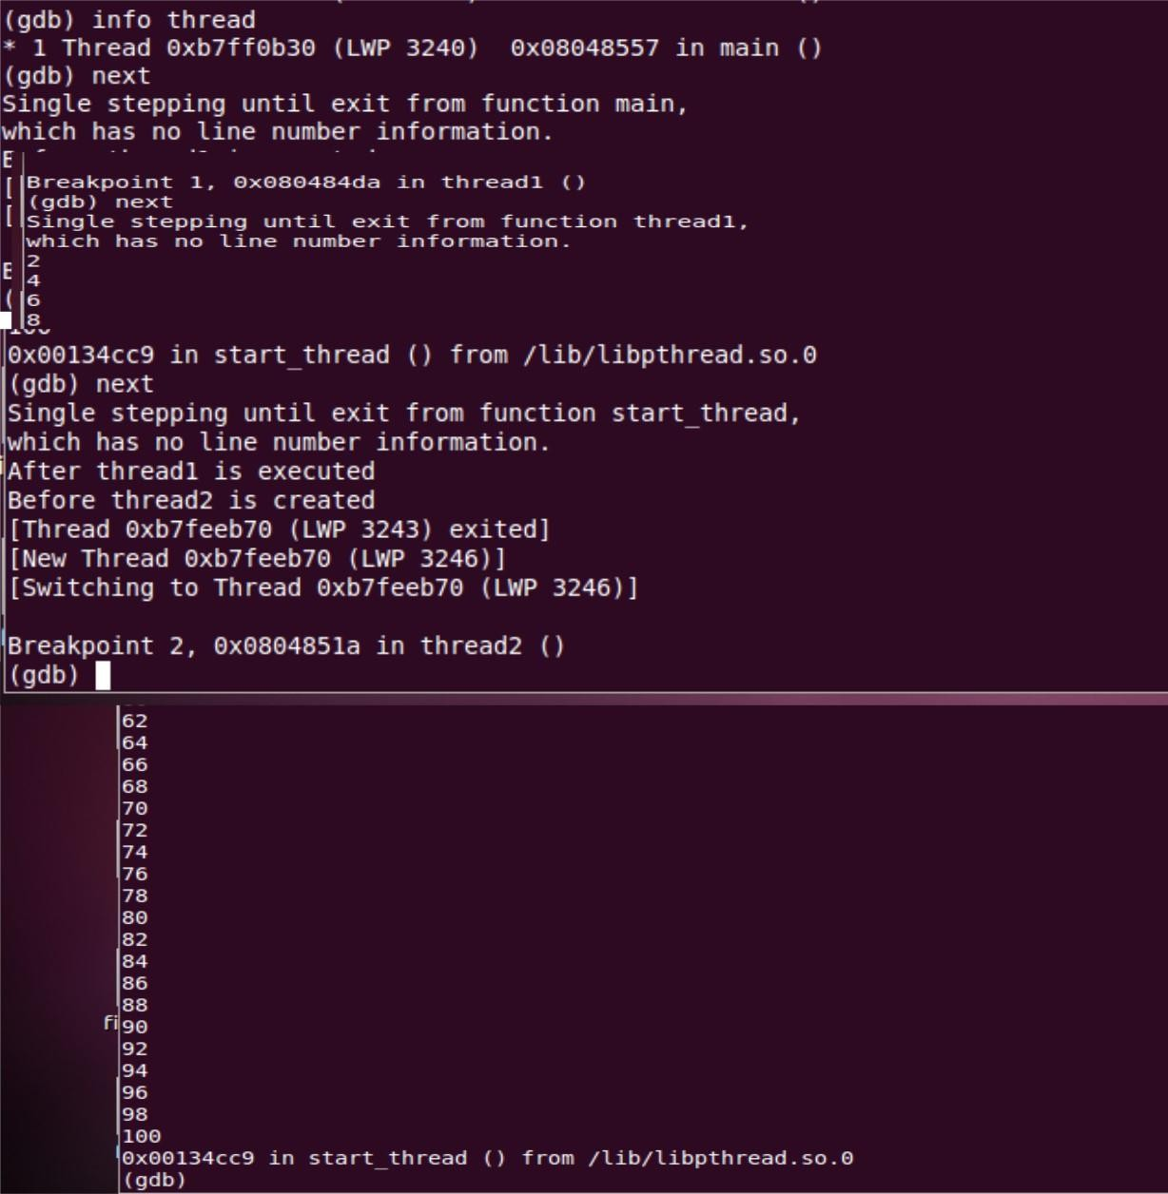
Fig. 1 Thread1: To display even numbers from 1-100

To write a c program to implement Threading and Synchronization Applications.

ALGORITHM:

Step 1: Start the process
Step 2: Declare process thread, thread-id.
Step 3: Read the process thread and thread state.
Step 4: Check the process thread equals to thread-id by using if condition. Step 5: Check the error state of the thread.
Step 6: Display the completed thread process.
Step 7: Stop the process

PROGRAM:

#include<stdio.h> #include<string.h> #include<pthread.h> #include<stdlib.h> #include<unistd.h>

pthread_t tid[2];
void* doSomeThing(void *arg)
{
unsigned long i = 0; pthread_t id = pthread_self(); if(pthread_equal(id,tid[0]))
{

}
else
{

}
printf("\n First thread processing\n");

printf("\n Second thread processing\n");

for(i=0; i<(0xFFFFFFFF);i++);
return NULL;
}
int main(void)
{
int i = 0; int err; while(i < 2)
{
err = pthread_create(&(tid[i]), NULL, &doSomeThing, NULL); if (err != 0)
{

}
else
{

} i++;
}
printf("\n can't create thread :[%s]", strerror(err));

printf("\n Thread created successfully\n");

sleep(5); return 0;
}

User Management:

  - Checking all/specific user accounts
$ lslogins < --user-accs/--system-accs>
$ lslogins <username> Example: $ lslogins bilal

  - Locating executables files
$ which <filename> Example: $ which find Example: $ which Example: $ which find
Which command show that where is the file in the directory.
  - Finding binary and source files for commands
$ whereis <name> Example: $ whereis find Example: $ whereis cat
  - To show currently logged in users in the system
$ who
$ w
$ users
$ last
$ top

  - To show current user
$ whoiam

  - To Substitute user with user name
$ su -<username> (if logged in as root then no password is required) Example $ su –bilal

  - To Substitute user as root
$ su - root

  - To execute command with Substitute user
$ su – c <command> – s <shell> <user>
Example $ su – c “echo Hello World” –s /bin/bash bilal

D. touch Command:

- Create file using touch command
- $ touch <-c> <filename1> <filename2> <filename3>
-c : to suppress creation if file does not exist
-t : to create file using specified date and time Example: $ touch OSLab5.1 OSLab5.2

- Create file using touch command by specifying date & time
$ touch <-t> <YYMMDDHHMM> <filename1>
-t : to create file using specified date and time Example: $ touch –t 2401231513 OSLab5.3

- Updating access and modification timings
$ touch <-c-d|-a|-m|-d|-r|> <filename1>
-c-d : to update access and modification time
-a : to update access time only
-m : to update last modification time only
-d : to update modification date only
-r : uses timestamp of one file to the other one Example: $ touch –d “05 May 2023” test.txt
$ touch –r source.txt destination.txt
Lab Tasks

- Create a file OSLabFile5.1 with date & time 25th January, 2025 3:00 PM.
- Find the binary and source file location of “ls” command
- Creates 5 threads each thread prints a "Hello World!" message, and then terminates.

